**Why Is Computer Upkeep So Important For Your Business?**

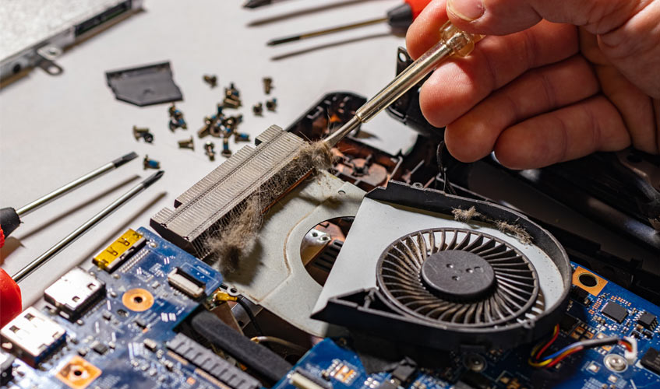

Your computer, no matter how expensive or smart it is, will eventually slow down. This is due to the fact that all machinery require routine maintenance and repair. Regrettably, most organisations are unaware of the importance of routine computer maintenance. As a result, they lose critical data and experience a severe reduction in production.

Because small businesses do not have a specialised IT department to handle software and hardware issues, the best option is to hire a full-service computer repair firm. M6 Repairs is a one-stop shop for any of your computer-related issues.

Viruses and malware can slow down your business computers, whether they are old or new - don't worry if you don't have a technical background. Please contact us if your employees' PCs are experiencing any connectivity or speed concerns.

The following are the top reasons why computer maintenance is so important for your company.

**Enjoy Faster Speeds**

Are you perplexed as to why your computer is running slower than usual? You might not realise it, but your computer's files get fractured and unorganised over time. As a result, your employees take longer to complete projects and miss critical deadlines.

Computer specialists can enhance loading times and speed up your equipment by doing frequent performance tests and smart optimization. Your teams won't have to deal with annoyances like waiting for software or files to load.

**Anti-Malware and Virus Protection**

Malware can disrupt operations and wipe critical data for any small or medium organisation. When your computer is infected with malware, it exhibits certain symptoms. The most prevalent indicators of an infected machine include slow loading speeds, frequent shutdowns, popup notifications, and getting unusual emails.

Corrupted IT systems quickly become a launch pad for infecting the machines of your business partners. Can you image how that would affect your professional relationships? No company wants their mailing address to be blacklisted by customers or business partners. That's why, in order to make long-term income, protecting your work computers from viruses and malware is critical. Professional computer maintenance services can assist you in repairing all IT flaws that expose your systems to hazards.

Because your antivirus application may not be sufficient to provide total protection, you should seek the services of a professional computer repair business.

**Updated Antivirus**

If your company's computers don't have the most up-to-date antivirus software, you're putting your IT security at danger. Prepare to deal with network security issues if your office personnel is ignoring key alerts from your antivirus applications. Businesses leak essential and sensitive data in some circumstances, which can have a negative influence on productivity. Regular computer maintenance checks, on the other hand, will ensure that your systems are secure.

**Software Efficiency**

Because they don't have the latest software, computers age and slow down over time. Outdated programmes and software might slow down your computer by taking longer to load. Furthermore, outdated software may lack the most up-to-date tools and features that can help your employees become more productive. When you plan frequent computer maintenance checkups, you can get the most out of your programme by using the most recent versions.

**Glitch-free Performance**

Even a minor hardware change can ensure that a computer runs smoothly and without interruptions. As a result, making timely computer repairs can save you money on future computer repairs. Replacing a motherboard, installing a new driver, or updating your machine's specifications can all help you increase output. Contact professional computer repair services if you want your staff to appreciate using a computer that is free of errors.

**More RAM**

When your work computers become slow or freeze, the first thing you should do is eliminate old software. You can also free up RAM by emptying your cache, deleting unneeded browser extensions, and updating your software. You can employ pros if you are unsure how to speed up your computer and delete apps that are eating up RAM space.

**Physical Maintenance**

Cleaning your computer by wiping the dust off of your keyboard and monitor is one option. You can safeguard your work PCs from general wear and tear by delegating this task to professional computer repair and maintenance services. Scratching can also be caused by dusty laptop displays.

A complete cleaning of your computer's electrical components, as well as the CPU fan, is required. With that in mind, make sure your computer has regular physical maintenance checks.

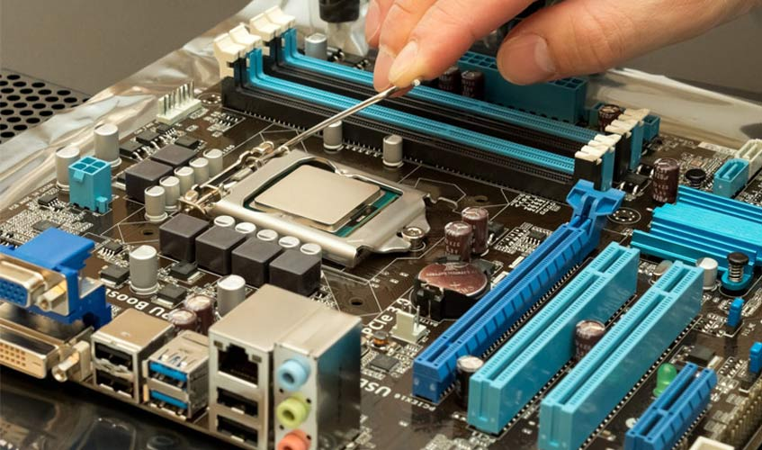

**Regular Backups**

Cleaning your computer by wiping the dust off of your keyboard and monitor is one option. You can safeguard your work PCs from general wear and tear by delegating this task to professional computer repair and maintenance services. Scratching can also be caused by dusty laptop displays.

A complete cleaning of your computer's electrical components, as well as the CPU fan, is required. With that in mind, make sure your computer has regular physical maintenance checks.

**M6 Repairs provides professional computer repair and maintenance services.**

M6 Repairs is only a phone call away, no matter how big or little your company is. Get skilled [computer repair](https://m6repairs.co.uk/) and maintenance services at a cheap price. Our qualified and experienced employees have the knowledge and abilities to assist your business become more productive. So that your staff don't have to struggle with slow and contaminated computers, our skilled IT hardware and software experts will repair them.